Compiler Design  
Lab Ex 1B

short line

**Aim: To implement the lexical analysis program to identify the keywords, operators and identifiers.**

**Procedure:**

1. **Open VS code editor**
2. **Write the code for Lexical Analysis in C++.**
3. **Write a code to be analysed and save it in the same folder.**
4. **Compile the code.**
5. **Execute the code.**
6. **The file hello.txt is lexically analysed.**
7. **Verify the output**

**Algorithm:**

1. **Initialize the keywords, identifiers and operators in the program.**
2. **At the start of a line, tokenize the indentation and skip any white–space**
3. **Tokenize the appropriate identifier, keyword, etc.**

**Code:**

#include<iostream>

#include<fstream>

#include<vector>

#include<cstdio>

#include<string>

#include<ctype.h>

using namespace std;

int isKeyword(char buffer[]){

    vector<string>keywords = {"auto","break","case","char","const","continue","default",

    "do","double","else","enum","extern","float","for","goto",

    "if","int","long","register","return","short","signed",

    "sizeof","static","struct","switch","typedef","union",

    "unsigned","void","volatile","while"};

    int i, flag = 0;

    for(i = 0; i < 32; ++i){

        if(keywords[i].compare(buffer) == 0){

            flag = 1;

            break;

        }

    }

    return flag;

}

int main(){

    char ch, buffer[15], operators[] = "+-*/%=", constants[] = "0123456789";

    ifstream fin("hello.txt");

    int i=0,j=0;

    if(!fin.is_open()){

        cout<<"error while opening the file\n";

        exit(0);

    }

    while(!fin.eof()){

        ch = fin.get();

        for(i = 0; i < 6; ++i){

            if(ch == operators[i])

            cout<<ch<<" is operator\n";

        }

        for(i=0; i<10; i++){

            if(ch == constants[i])

                cout<<ch<<" is constant\n";

        }

        if(isalnum(ch)){

            if(ch>=97 && ch<=122)

                buffer[j++] = ch;

        }

        else if((ch == ' ' || ch == '\n') && (j != 0)){

            buffer[j] = '\0';

            j = 0;

            if(isKeyword(buffer) == 1)

            cout<<buffer<<" is keyword\n";

            else

            cout<<buffer<<" is non-identifier\n";

        }

    }

    fin.close();

    return 0;

}

**Text file containing program to be Analysed:**

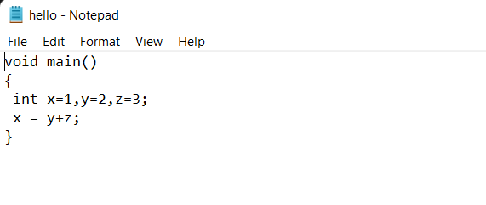

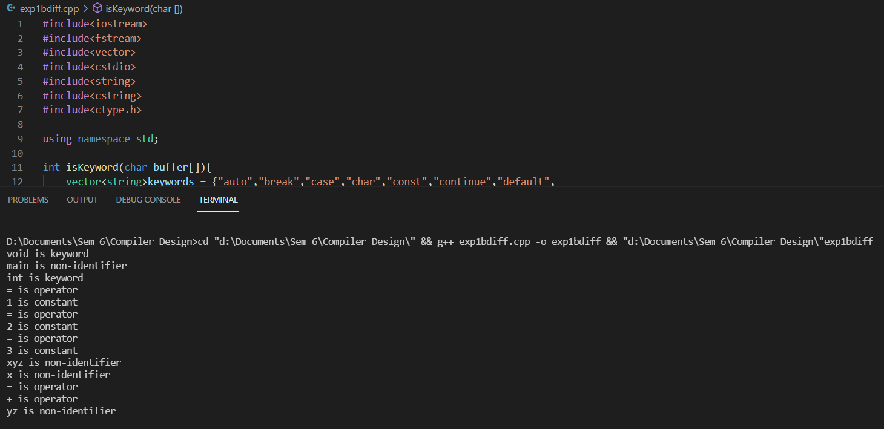**Output:**

**Conclusion: The given code to the sum of 2 numbers has been analysed lexically.**